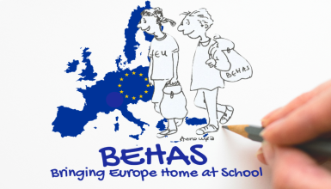

**Choose a category to refer your project/activity to:**

|  |  |  |  |  |  |
| --- | --- | --- | --- | --- | --- |
| **Info-days European chocolate Day** | **CLIL theory and lessons** | **Lesson plans for the European Day** | **Quizzes and games** | **Literature/reading**  **and languages** | **Artistic Education**  **ν** |

A CHOCOLATE ADVENTURE A3

Once upon a time in the 3rd Primary School, the class of A3 and its teacher decided to go on a little voyage.

In the port there was a chocolate ship waiting for them which also transported cocoa.

They travelled the seas until they reached a small island.

They got off the ship and had a rest.

They saw lollipop trees and put up their tents under their shades.

They fell asleep in their tents in order to be fresh the next morning.

Early at dawn, they took a long walk to explore the island.

They reached a mountain that was high and was made out of chocolate fudge.

They climbed up high and saw the whole island from the top,

and then they slid down its slope.

They fell into a chocolate pond full of fruity llily pads.

They got out of the pond, and run on the beach and gathered sea shells like never before.

What chocolate gifts were these dusted with sugar!

The children got warm from the games and started diving in the sea.

As soon as they were through with this, they started chasing each other

in a forest made of sweets.

They discovered at the tree tops that the beautiful birds

had made nests and had filled them with chocolate eggs.

What pleasure! What happiness! They’d adore to eat them all.

It’s a chocolate madness and it has affected all children.

They played and ate until they were full

And then they went to sleep with their bellies full.

So they lived happily ever after

And I wish your life is as sweet as chocolate hereafter.

